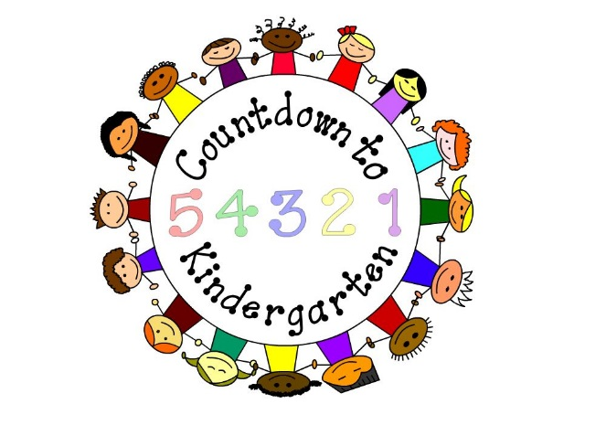

***Any child who has registered for***

***kindergarten in Fayette County Public***

***Schools can take their T-shirt coupon and***

***pick up a free Countdown to Kindergarten***

***T-shirt at any Lexington Public Library***

***branch starting May 1.***

***The T-shirt becomes your child’s ticket***

***to each of the events below.***

**June 1 - 5 Lexington Public Library -- “Discover Summer Kick-Off Parties!”** Kindergarteners can pick up their   
Countdown to Kindergarten shirts with coupon at any library location. Join the party, and get your reading log and a calendar of events for the summer. We will have special handouts just for you!

* **June 1, 10 a.m. – noon at Tates Creek Branch, 2 - 4 p.m. at Beaumont Branch**
* **June 2, 10 a.m. - noon at Central Library, 2 - 4 p.m. at Northside Branch**
* **June 4, 2 – 4 p.m. at Village Branch**
* **June 5, 10 a.m. - noon at Eastside Branch**

**Saturday, June 9, from 2 to 4 p.m. – The Kentucky Children’s Garden at the Arboretum – 500 Alumni Drive**

Come join in the fun! Learn about butterfly life cycles, plant a seed to take home, and explore how the garden is blooming. Free admission is only for kindergartner with a C to K shirt and one adult; others $3 per person.

**Saturday, June 16, from 10 a.m. to noon – Lexington Children’s Theatre– 418 West Short Street**

Join the Lexington Children’s Theatre as we delve into “Where the Wild Things Are.” Explore your actor’s tools, make a mask, and act out this fabulous story. Free admission is only for kindergartner with a C to K shirt and one adult. Register at www.lctonstage.org before June 14.

**Saturday, June 16, Parks and Recreation pools**

Enjoy a day of swimming at any city pool. Free admission is only for kindergartner with C to K shirt. Please check each pool’s location for hours and the cost for additional guests.

**Saturday, June 23, from 10 a.m. to 2 p.m. – Living Arts and Science Center – 362 N. Martin Luther King Blvd.**

Check out this special Discovery Saturday program featuring hands-on exhibits, art and makerspace activities, live animals, a planetarium show, and more! Free admission is only for kindergartener with a C to K shirt and one adult. Additional guests are $5 each.

**Saturday, June 30, from 9 to 11 a.m. – North Lexington Family YMCA - 381 West Loudon Ave.**

Parents and children can participate in a variety of self-directed activities to support school readiness through physical activity, art, and science. Activities will included an obstacle course, a science experiment, and a craft. Admission for the whole family is included when accompanied by a kindergartener in a C to K shirt.

**Saturday, July 7, from 11 a.m. to 12:30 p.m. -- Lexington Philharmonic Concert at the Carnegie Center – |  
251 West Second Street**

Bring your family to hear some poetry and stories paired with music and then collaborate with LexPhil musicians to create your own story and adventure. Pre-concert activities include an instrument petting zoo, musical crafts, coloring pages, and more. It’s free for the child in a C to K shirt and one parent; $5 for all others.

**Saturday, July 14, from 10 a.m. to noon – Bluegrass Greensource - 835 National Ave.**

Learn about water quality while participating in hands-on activities. Paint a fish print, go fishing for pollution, make a pool noodle boat, and more. Free admission for the child in a C to K shirt and their families.

**Saturday, July 21, 11 a.m. -- Explorium – 440 West Short Street**

Come see our free show that oozes, fizzes, and kabooms! Museum entry is also free for a child in a C to K shirt; $8 for others. Email Kalli Turner at [turner@explorium.com](mailto:turner@explorium.com) for reservations.

**Saturday, July 28, from 10 to 11:30 a.m. – Bluegrass Youth Ballet - 1595 Mercer Road, Suite 180**

Come see how ballet moves you! Kindergartners in C to K shirts can join us for ballet class, demonstrations, and activity. It’s free for a child in their C to K shirt and one parent. Please call (859) 271-4472 or email [info@bluegrassyouthballet.org](mailto:info@bluegrassyouthballet.org) to register.

**Saturday, July 28, from 9 a.m. to 5 p.m. – McConnell Springs Nature Park – 416 Rebmann Road**

Children and their families will participate in a nature scavenger hunt. Free admission for children in C to K shirts and their families.

**Sunday, July 29, Lexington Legends baseball “Barn at the Park” - Whitaker Bank Ballpark. Gates open at 1 p.m. and the game starts at 2 p.m.** Activities for kindergarteners include running the bases at the end of the game and Triple Play Zone fun! Free admission for all children under 12; adults with a kindergartner get in for $5. To register, call the box office at (859) 422-7867; tickets can be picked up at the will call tent on game day. Tickets also may be purchased that afternoon at any box office window. Your child must be wearing a Countdown to Kindergarten shirt to receive the discount.

**Saturday, August 4 -- Back to School Rallies**

The YMCA of Central Kentucky hosts Back to School Rallies each year across the city. For information on locations and other details, go to [www.ymcacky.org/childcare/back-to-school-rallies/](http://www.ymcacky.org/childcare/back-to-school-rallies/)

**Saturday, August 4, Parks and Recreation pools**

Enjoy a day of swimming at any city pool. Free admission is only for kindergartner with C to K shirt. Please check each pool location for hours and admission prices.

**Saturday, August 11, 9 a.m. to 3:30 p.m. - KET - 600 Cooper Drive**

KET wants to help your little one get ready for kindergarten with “Super Saturday 2018.” Children in C to K shirts plus one accompanying adult (two if there is room) are invited to a special zone in the KET Media Lab. Each child will leave with a book and activities to do at home. Register at [www.ket.org/supersaturday](http://www.ket.org/supersaturday) starting June 15.









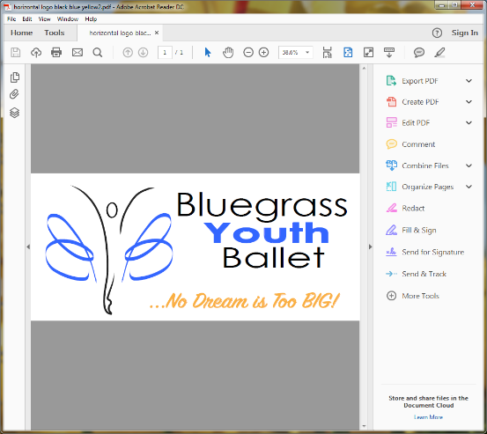cid:image003.jpg@01D093C9.D25F60C0C:\Users\mzdavis\AppData\Local\Microsoft\Windows\Temporary Internet Files\Content.Outlook\H9BIYD31\McConnell Springs Logo (2).TIF